**Performance Comparison for ANN and CNN model**

1. The performance matrix used for evaluation of both the models is root mean square error and mean absolute error.
2. Below are the graph plots of predictions done using both the model:

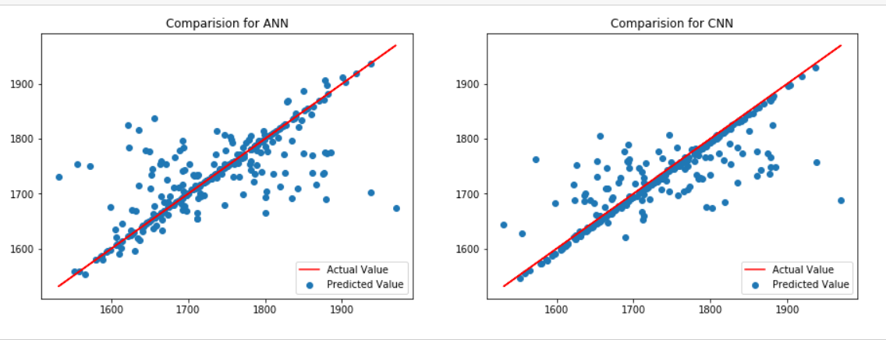

*Figure 1. Linear plot for actual optimized values vs scatter plot of predicted value*

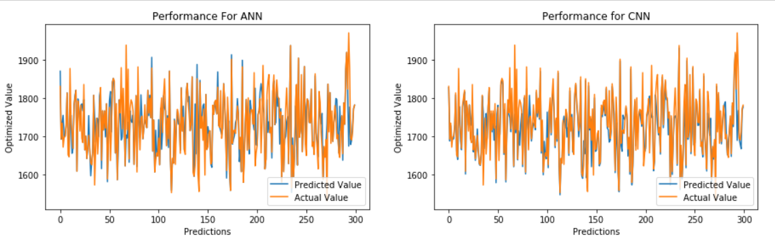

*Figure 2. Plot to show the comparison of prediction performance by both models*

1. The experiment showed that **CNN model performed better on the dataset for predicted of the optimal time as compared to ANN.**
2. CNN performed better as it does some feature scaling which helped to increase the performance.
3. Also, including batch normalization in CNN model, showed a good decrease in the error value while prediction.
4. Below is the screenshot of the performance metrics calculated for predictions:

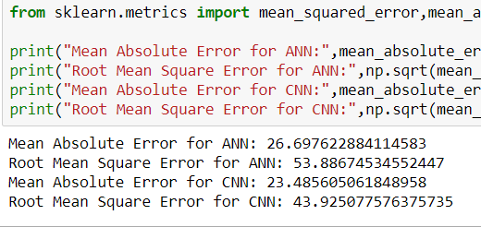

*Figure 3. Comparison of Performance metrices for both models*